[11 January 2011]
The connection of the HTC Legend was still not ideal as it seemed a bit slow and I think this was due to the HTC Sync way of connecting the device. I decided I will spend a little more time in investigating this issue.
After going through lots of not very useful suggestions in websites, I mentioned this to my colleague Alexandros Schillings, we both work in the University of Essex’s Audiovisual and Media (AVMS) Department. He told me that I do not need to use the HTC Sync and gave me a link to his blog[1] where he has shown how to make a connection to a similar Android device without the HTC Sync.
[1]“alt236: ADB driver installation fails after ROM update or change.” [Online]. Available: http://alt236.blogspot.com/2010/09/adb-will-not-detect-phone-after-rom.html. [Accessed: 11-Jan-2011].
Using the methodology shown in the blog I managed to implement the connection to the device without the need of HTC Sync successfully.
After this debugging on the device was more responsive and less painful.
[3 hours]

[12 January 2011]
After spending a considerable amount of the day in research I can successfully confirm that for the purpose of this project, for mapping the best way of implementation would be to use the Google Maps API[1].
One of my ideas was to use digital images of the university or digital maps of the university but this methodology is not suitable for mapping, it is not well supported by Android for this purpose and it would lead to high complexity and inaccuracy and in the worse case implementation impossibility.
On the other hand Android offers powerful mapping capabilities by using Google Maps Libraries and wrappers around Google Maps API.[2]
What I have found out which supports my decision is as follows:
- Best Android support
- Stable when running on an Android device
- Offers an enormous extent of functionality and flexibility compared to other methodologies for the purpose of the project

[1]“Google Maps API Family - Google Code.” [Online]. Available: http://code.google.com/apis/maps/index.html. [Accessed: 12-Jan-2011].
[2]“Location and Maps | Android Developers.” [Online]. Available: http://developer.android.com/guide/topics/location/index.html. [Accessed: 12-Jan-2011].
[4 hours]

[19 January 2011]
Trying to implement a simple Google Map in an Android application.
Following Android Developers tutorial[1].
[1]“Google Map View | Android Developers.” [Online]. Available: http://developer.android.com/resources/tutorials/views/hello-mapview.html. [Accessed: 19-Jan-2011].

Started implementing a Map Activity – to support mapping.
Ran into a difficulty – in order for to be able to use Google Maps I have to obtain a Maps API Key. This key is used when signing the application.
Researching and learning how to obtain needed Key[2].
[2]“Obtaining a Maps API Key - Google Projects for Android.” [Online]. Available: http://code.google.com/android/add-ons/google-apis/mapkey.html. [Accessed: 19-Jan-2011].
Working on obtaining the key and adapting the development environment to support the key – not so straightforward.
Since for the time being I will not be signing and releasing the application I have obtained a debugging Key (SDK Debug Certificate) to use for Google Maps API mapping.
[4 hours]

[20 January 2011]
Working on implementing a simple Google Map application. Now that I have the SDK Debug Certificate and following the Android Developers Tutorial, first I created a new project and set it to compile for Android 2.2 OS with Google APIs since if it was just for Android 2.2 the map functionality would not work.
Set up needed parameters and permissions, for example accessing internet to dynamically download map tiles, in the project’s “AndroidManifest.xml” and other relevant xml files such as layouts to support and display maps.
Created a class to extend MapActivity (subclass of Android’s Activity).
Set up a new MapView in the class and enabled built-in zoom controls for controlling the view.
Hardcoded an example MapOverlay item with the university’s square 3 coordinates.
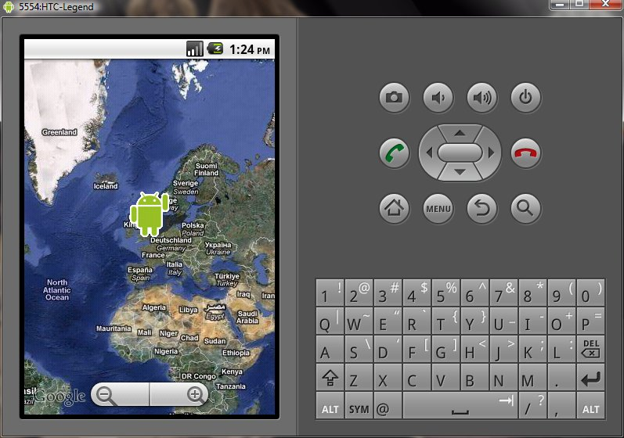
Simple Google Map
Also learned how to implement a “on tap” action which displays specified text when an overlay item sis tapped.
It worked!
*Note: It is easier for me to take screenshots of the SDK emulator, rather than taking photos of the HTC phone. This is why most/all images showing an application are from the emulator.
Further researched how to turn on satellite view programmatically, by using:
mapView.setSatellite(true);
[6 hours]
[22 January 2011]
Working on adding Location services to the simple Google Map application.
I want to be able to get the user’s current location.
After researching, decided to follow another Android Developer’s Tutorial[1].
[1]“Obtaining User Location | Android Developers.” [Online]. Available: http://developer.android.com/guide/topics/location/obtaining-user-location.html. [Accessed: 22-Jan-2011].

Challenges met in obtaining user location:
- Choosing the best location information source
  - GPS – provides more consistent location information but not very accurate
  - CellID – less consistent information, not accurate enough
  - Wi-Fi – less consistent location information, not accurate enough
  - Have to consider trade-offs such as: accuracy, speed, battery-life
- Considering refresh rate due to user movement
[2 hours]

[25 January 2011]
I am facing the difficult choice as to what location provider to use.
Looking for solution, suitable for the purpose of the project as I would like to have accuracy between 5 – 3 meters.
I already know that neither GPS[1], CellID[2] or Wi-Fi[3] alone by themselves have accuracies varying from 5 – 100 meters depending on different factors such as satellite or cell density and availability. This is not ideal for the location module of the application.
[1]“Global Positioning System - Wikipedia, the free encyclopedia.” [Online]. Available: http://en.wikipedia.org/wiki/Global_Positioning_System. [Accessed: 25-Jan-2011].
[2]“Cell ID - Wikipedia, the free encyclopedia.” [Online]. Available: http://en.wikipedia.org/wiki/Cell_ID. [Accessed: 25-Jan-2011].
[3]“Wi-Fi - Wikipedia, the free encyclopedia.” [Online]. Available: http://en.wikipedia.org/wiki/Wi-Fi. [Accessed: 25-Jan-2011].
After researching for solutions and alternatives for several more hours I have come up with a decision. I will implement Assisted GPS (aGPS)[4] opposed to pure GPS using a Hybrid Positioning System[7]. This will be possible thanks to the Android’s APIs and Libraries which allow me to listen on GPS, Cell and Wi-Fi providers at the same time and they help each other in the background.
[4]“Assisted GPS - Wikipedia, the free encyclopedia.” [Online]. Available: http://en.wikipedia.org/wiki/Assisted_GPS. [Accessed: 25-Jan-2011].
[5]“What’s ‘assisted GPS’?? - Android Forums.”[Online]. Available: http://forum.androidcentral.com/android-central-lounge/8416-whats-assisted-gps.html. [Accessed: 25-Jan-2011].
[6]“What is assisted GPS - Android - Stack Exchange.” [Online]. Available: http://android.stackexchange.com/questions/1522/what-is-assisted-gps. [Accessed: 25-Jan-2011].
[7]“Hybrid positioning system - Wikipedia, the free encyclopedia.” [Online]. Available: http://en.wikipedia.org/wiki/Hybrid_positioning_system. [Accessed: 25-Jan-2011].
Assisted GPS (aGPS)[4][5][6] is when the GPS provider is aided by other network providers, such as GSM Cell and Wi-Fi, to connect, lock and get accurate position quicker. Upon start-up the Smartphone initially gets the location via cell tower triangulation, while it waits for the GPS module to lock on satellites and tune the location. Also initial location or positions of satellites can be obtained, from Wi-Fi as data such as time or orbital data.
As far as I am aware Android also supports a kind of Wi-Fi Positioning System[8] in the background, which gets a position based on measuring the intensity of the received signal or “fingerprinting”[9], which allows me also to rely on Wi-Fi.
[8]“Wi-Fi Positioning System - Wikipedia, the free encyclopedia.” [Online]. Available: http://en.wikipedia.org/wiki/Wi-Fi_Positioning_System. [Accessed: 25-Jan-2011].
[9]“Device fingerprint - Wikipedia, the free encyclopedia.” [Online]. Available: http://en.wikipedia.org/wiki/Device_fingerprint. [Accessed: 25-Jan-2011].
Performance and battery life will vary depending on the quality of the Cell Tower signal and Wi-Fi data able to receive. GPS consumes a lot of battery energy, but the overhead of the assistants is minimal, if in good conditions. Also if Assisted-GPS is used battery life can be extended as the user will be able to get a GPS fix faster and finish using it quicker as well, so less energy will be consumed.
[6 hours]

[26 January 2011]
Following the tutorial and keeping in mind the challenges I have to overcome I started by adding to the existing project a new class for location services.
Set up needed parameters and permissions in project’s “AndroidManifest.xml” file to allow internet access and fine localization capabilities by adding:
<uses-permission android:name="android.permission.INTERNET" />
<uses-permission android:name="android.permission.ACCESS_FINE_LOCATION" />
In the constructor I am passing the application context, so that I can refer to it and the MapActivity.
I created a new LocationManager and acquired a reference to the system’s Location Manager. This will allow me to use location services.
I implemented a LocationListener which will listen for location changes. It is listening for updates on both Android’s GPS Provider and Network Provider. The Network Provider delivers updates from Cell Towers and Wi-Fi.
In the onLocationChanged() method which is triggered by the listener I obtain the location’s latitude and longitude.
I ran into a problem as I need to find a way to convert the GPS coordinates into Google Maps coordinates.
[5 hours]

[28 January 2011]
I am looking for a way to convert the Android Location coordinates to the Google Maps API coordinates, so I can display the current location on the map.
I found out that I need to convert the Android Location coordinates which are of the type double to the Google Maps API coordinates which are of type integer. I need to find a way to do this without mismatching the location information.
I found a formula, which will work for me, in this topic[1] and I am using it like this and it works:
latit = (int) (location.getLatitude() * 1E6);
longtit = (int) (location.getLongitude() * 1E6);
[1]“How to display lines created in android in web google maps? - Stack Overflow.” [Online]. Available: http://stackoverflow.com/questions/3179399/how-to-display-lines-created-in-android-in-web-google-maps. [Accessed: 28-Jan-2011].
[5 hours]

[30 January 2011]
I am looking for a way to improve my location class as it is not very accurate and hard to manipulate.
After researching I decided I will be considering:
- When to start listening for updates
- Maintaining awareness of last known location until a more accurate location is obtained
- Tuning to save battery and lower data exchange rates as this might be expensive
  - For example less frequent updates which would save battery life but a trade-off would be accuracy
While doing further research of how to implement the targeted adjustments I came across this topic “What is the simplest and most robust way to get the user's current location in Android? “[1], in which there is a posted example of a very good location class, which just might suit my needs. The example of “methodology”[1] and “location class”[1] are posted by the user “Fedor”[1] and so far it seems that they are in line with the methodology I intended to use.
[1]“geolocation - What is the simplest and most robust way to get the user’s current location in Android? - Stack Overflow.” [Online]. Available: http://stackoverflow.com/questions/3145089/what-is-the-simplest-and-most-robust-way-to-get-the-users-current-location-in-an/3145655#3145655. [Accessed: 30-Jan-2011].
I am considering of using this class, or parts of it in my project.
[3 hours]

[01 February 2011]
Upon closer inspection of the location class I had come across it seems to be exactly what I need:
- It is implementing an Assisted-GPS
- It starts listening when and if only a provider is made available intentionally by the user, for example if the user has switched on the device’s GPS on
- It is maintaining awareness of last know location from both GPS and Network providers
After tinkering with it and trying to test it I have ran into a problem as this location class is to be used with callback class and this is quite hard for me to implement in Android.
After a bit more tinkering I managed to get it working and it is working quite well. I can see coordinates in my debugging information.
After a bit more testing I have discovered several issues with this location class:
- It has next to none consideration for battery consumption
- For some reason it does not listen to the GPS provider, even though it is supposed to, and is working only with the Network provider which does not deliver the required level of accuracy
[5 hours]

[03 February 2011]
I continue working on the Location class.
I tried displaying the coordinates I got from the Location class in my Map class but I ran into difficulties.
In Android only the main thread from the main Activity can manipulate the MapView and since I am using a callback class this is creating a conflict.
I am searching for a way to overcome this issue.
I tried using a Java Timer[1], but this does not work well in Android and did not help.
[1]“Timer | Android Developers.” [Online]. Available: http://developer.android.com/reference/java/util/Timer.html. [Accessed: 03-Feb-2011].
Tried creating a new Thread[2] to handle the task, but this did not work as it was still not the Main Thread to do the manipulation.
[2]“Thread | Android Developers.” [Online]. Available: http://developer.android.com/reference/java/lang/Thread.html. [Accessed: 03-Feb-2011].
I tried using Runnable[3] to execute a command in the Main Thread, as Runnables can execute commands in different threads and thus force my refresh in the Main Thread, but it would still not work as it would not force the call of my method.
[3]“Runnable | Android Developers.” [Online]. Available: http://developer.android.com/reference/java/lang/Runnable.html. [Accessed: 03-Feb-2011].
I researched the possibility of using an Android Handler[4] as it would allow me to send and process Message and Runnable objects associated with a thread’s MessageQueue[4] but it would still fail when I tried to associate it with the Main Thread.
[4]“Handler | Android Developers.” [Online]. Available: http://developer.android.com/reference/android/os/Handler.html. [Accessed: 03-Feb-2011].
I also tried implementing a TimerTask[5] and represent my method as a task to be run at a specific time by the Main Thread and this failed as well because the new TimerTask was creating a new Thread outside the Main Thread.
[5]“TimerTask | Android Developers.” [Online]. Available: http://developer.android.com/reference/java/util/TimerTask.html. [Accessed: 03-Feb-2011].

Finally I found out how to the Map update problem in this article “Updating the UI from a Timer”[6]. Here the people from Android explain their specific decision not to support Java Timer as it would consume the already scarce resources available on a mobile device without justification by creating new threads. This is why they have replaced the role of the Timer with this one of an Android Handler which runs the code as part of my Main Thread and avoids the overhead of a second thread.
Following the methodology in the examples[6], I corrected my previous effort using a Handler and I managed to implement a successful solution using a Handler and Runnable.
[6]“Updating the UI from a Timer | Android Developers.” [Online]. Available: http://developer.android.com/resources/articles/timed-ui-updates.html. [Accessed: 03-Feb-2011].
[6 hours]

[05 February 2011]
I decided to leave the technical difficulties with the Location class for later and to move to something else, otherwise I would be grinding on the same place.
I already knew that Android uses SQLite databases, so I researched how does the OS exactly support Data storage.
SQLite is a light-weight version of SQL designed to run on devices with less resources like mobile devices. I found out that the database support is quite flexible and as well I can make use of internal or external storage on the mobile device.[1]
[1]“Data Storage | Android Developers.” [Online]. Available: http://developer.android.com/guide/topics/data/data-storage.html#db. [Accessed: 05-Feb-2011].

I found the following tutorial “Creating and Using Databases in Android.”[2] and since it seemed very practical I decided to go through it.
[2]“Creating and Using Databases in Android.” [Online]. Available: http://www.devx.com/wireless/Article/40842. [Accessed: 05-Feb-2011].
I created a simple database using SQLiteStudio.
I included the database in the project structure.
Following the tutorial I created a DatabaseAdapter class which would take care of the connection to the database.
I created some methods for inserting and displaying entries in the database. It worked.
Following the tutorial I created some methods for updating and deleting entries in the database.
[5 hours]

[09 February 2011]
Today I was talking again to my work colleague Alexandros Schillings (Alex) about my project since he is an Android developer as well. I asked him for support and advice and he was very helpful.
One of the really good hints was to move the database to the external storage (SD Memory Card) of the Android mobile device. This way it would be more decoupled from the application and easier to update in the future, for example if frequent updates are released.
Currently researching how to move the database to the SD Memory Card of the HTC Legend.
I found and tested a methodology about creating a database in external memory using described in anddev.org[1]:
SQLiteDatabase.openDatabase("DATABASE PATH", null, SQLiteDatabase.OPEN_READWRITE + SQLiteDatabase.CREATE_IF_NECESSARY);[1]
It did not work very well, so I decided I will continue until I have it right.
[1]“anddev.org • View topic - Creating database on sdcard ...” [Online]. Available: http://www.anddev.org/creating_database_on_sdcard_-t7817.html. [Accessed: 09-Feb-2011].
Going through “Using your own SQLite database in Android applications”[2] gave me some good ideas.
[2]“Using your own SQLite database in Android applications | ReignDesign Blog.” [Online]. Available: http://www.reigndesign.com/blog/using-your-own-sqlite-database-in-android-applications/comment-page-1/. [Accessed: 09-Feb-2011].

In the end I settled for using:
getExternalStorageDirectory()[3]
as this is the most efficient way of manipulating a database on external memory.
[3]“Environment | Android Developers.” [Online]. Available: http://developer.android.com/reference/android/os/Environment.html#getExternalStorageDirectory%28%29. [Accessed: 09-Feb-2011].
[4 hours]

[10 February 2011]
I decided to research the possibility of showing paths on the map and if it is easy and not time consuming for the purpose of this project to implement it.
After spending some time in research it turns out that it is by far not an easy task. The example in the following topic[1] does not work and the topic itself was not finished.
[1]“java - Overlay only draws line between first 2 GPS points in Android - Stack Overflow.” [Online]. Available: http://stackoverflow.com/questions/2538984/overlay-only-draws-line-between-first-2-gps-points-in-android. [Accessed: 10-Feb-2011].
Found another topic[2] with problems in creating Paths.
[2]“GeoPoint Path Issue? - Android Developers | Google Groups.” [Online]. Available: http://groups.google.com/group/android-developers/browse_thread/thread/48834b493e184f7e. [Accessed: 10-Feb-2011].
This topic[3] gave me some ideas of using “projection” and “toPixels” and I made some unsuccessful attempts.
[3]“java - Android - drawing path as overlay on MapView - Stack Overflow.” [Online]. Available: http://stackoverflow.com/questions/3036139/android-drawing-path-as-overlay-on-mapview. [Accessed: 10-Feb-2011].
From this topic[4] I got a good idea about using “MapRouteOverlay()” and inserting it along in the MapView with the other overlay items.
[4]“Android draw route on a Mapview with twoo POI-s - Stack Overflow.” [Online]. Available: http://stackoverflow.com/questions/4408671/android-draw-route-on-a-mapview-with-twoo-poi-s. [Accessed: 10-Feb-2011].
Some more useful examples, even if they are not working.[5]
[5]“android - Drawing a line/path on Google Maps - Stack Overflow.” [Online]. Available: http://stackoverflow.com/questions/2176397/drawing-a-line-path-on-google-maps. [Accessed: 10-Feb-2011].
In the following topic “How To Program Google Android.” I found a lot of useful information and code snippets but I did not want to use them all to avoid plagiarism and as well I wanted to follow my own ideas and ways of implementation. A very useful example which I think I will implement as a feature was using “MapView.getController()” to obtain the map controller and use it to animate the map to particular coordinates. This way I can scroll the map automatically without the user interacting with it.
[6]“How To Program Google Android.” [Online]. Available: http://blogoscoped.com/archive/2008-12-15-n14.html. [Accessed: 10-Feb-2011].
[4 hours]
[11 February 2011]
The lack of success with Paths due to the complexity of implementation drove me to think about something else. I decided to research the possibility of implementing a routing algorithm. For example utilizing Dijkstra's[1] algorithm for shortest path problems and maybe working on actually drawing the paths later.
[1]“Dijkstra’s algorithm - Wikipedia, the free encyclopedia.” [Online]. Available: http://en.wikipedia.org/wiki/Dijkstra%27s_algorithm. [Accessed: 11-Feb-2011].
I started searching for possible ways of implementing a routing algorithm.
I found a very helpful website[2] in which there were various examples of ways of calculating latitude and longitude points with formulas and code snippets.
The only downside so far is that everything is far too complex for the time window which I have for this project.
[2]“Calculate distance and bearing between two Latitude/Longitude points using Haversine formula in JavaScript.” [Online]. Available: http://www.movable-type.co.uk/scripts/latlong.html. [Accessed: 11-Feb-2011].
One of the formulas which seemed appropriate was “Vincenty’s ellipsoidal formula”[3] as it is for finding the distance of two points using an ellipsoidal model and was creating for calculating geodesic distances between points on Earth’s surface.[3]
[3]“Vincenty ellipsoidal formula for geodetic distance between two Latitude/Longitude points in JavaScript | Movable Type Scripts.” [Online]. Available: http://www.movable-type.co.uk/scripts/latlong-vincenty.html. [Accessed: 11-Feb-2011].
Found another topic - “Calculate distance between two points on a globe.”[4] With very useful code examples using a different formula - Haversine Formula. But this one is for calculating distances between two points on a sphere.[4]
[4]“Calculate distance between two points on a globe.” [Online]. Available: http://www.codecodex.com/wiki/Calculate_Distance_Between_Two_Points_on_a_Globe. [Accessed: 11-Feb-2011].

I came across the following project[5] about developing applications for Vanderbilt University. There were some very good features which I think I would be able to incorporate in my project in the future[5]:
- Distance from your current GPS position
- Locations on/off campus
- Alphabetical listing of locations
- Time until location opens or closes
- Kind of location (Sushi, Thai, etc)
- See all buildings on campus
- See building pictures, distance, and description
- See event locations on the map
[5]“vuphone - Vanderbilt University Applications for iPhone and Google Android - Google Project Hosting.” [Online]. Available: http://code.google.com/p/vuphone/. [Accessed: 11-Feb-2011].
[5 hours]

[16 February 2011]
After so much time and effort spent on Distances and Paths I had a successful result of being able to draw a path between two GeoPoints:
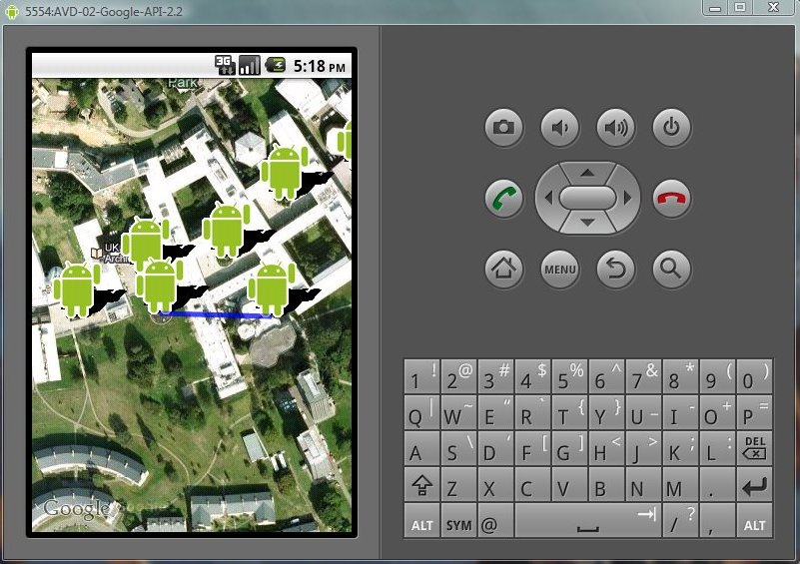
Google Map Path

Applying my project management skills and having in consideration the complexity and the discussion I had with my Supervisor, Professor Huosheng Hu, I decided that a Routing Algorithm and Path displays are not important now and I will move on to something more urgent.
I already knew how to add Map Overlay items and also how to manipulate “on tap” actions and displaying a dialog box using “AlertDialog.Builder”.
The next thing I thought myself to do was using “toasts”[1] and also how to customize them. The difference between a “toast” message and a dialog box is that the Android toast message only fills the amount of space required and not the whole window, without disrupting the user’s activity, it also fades in and out automatically and does not accept interaction events.[1]
[1]“Creating Toast Notifications | Android Developers.” [Online]. Available: http://developer.android.com/guide/topics/ui/notifiers/toasts.html. [Accessed: 16-Feb-2011].

Successfully managed to master the creation and manipulation of toasts and custom toasts.
Currently experimenting with different overlay images. Found some very precise ones, google maps icons[1], which fit perfectly as they are created for Google Maps.
[2]“google-maps-icons - More than 1000 free and descriptive map POI markers, icons, for your maps - Google Project Hosting.” [Online]. Available: http://code.google.com/p/google-maps-icons/. [Accessed: 16-Feb-2011].
Now I have several different ways of presenting text information:
- In plain text – to be used in GUI
- As toast – to be used where user interaction is not required
- As Alert Box – to be used where user interaction is required
- Map Overlays – visually presenting information and orientation
[5 hours]

[17 February 2011]
Applying my management skills I have decided that I will be focusing on the Graphical User Interface (GUI) for now.
After going through Android’s “User Interface Guidelines”[1] and taking on board some of the recommended best practises and also keeping in mind my previous sketches and ideas about the UI (User Interface), I have decided that I will apply a “tabbed” interface design as it would provided the required flexibility of switching between searching, text and map information.
[1]“User Interface Guidelines | Android Developers.” [Online]. Available: http://developer.android.com/guide/practices/ui_guidelines/index.html. [Accessed: 17-Feb-2011].
I successfully went through the Android Tabs tutorial[2] and implemented a simple Tab GUI.
[2]“Tab Layout | Android Developers.” [Online]. Available: http://developer.android.com/resources/tutorials/views/hello-tabwidget.html. [Accessed: 17-Feb-2011].
Even after the good results I am still not happy with the way the whole lot of it work as it seems to be awkward and not as flexible as expected. I will come back to this later.
[4 hours]

[18 February 2011]
Now after using the simple database so far for testing and after making changes to it as I went, today I am polishing it and also finishing inserting data into it.
Some of the data is made up by me as I go for testing and proof of concept. For the rest of the data, such as rooms, buildings, I have been using data made available by the University of Essex Colchester Campus Guide[1].
[1]“University of Essex :: Colchester Campus guide.” [Online]. Available: http://www.essex.ac.uk/colchester/guide.aspx. [Accessed: 18-Feb-2011].
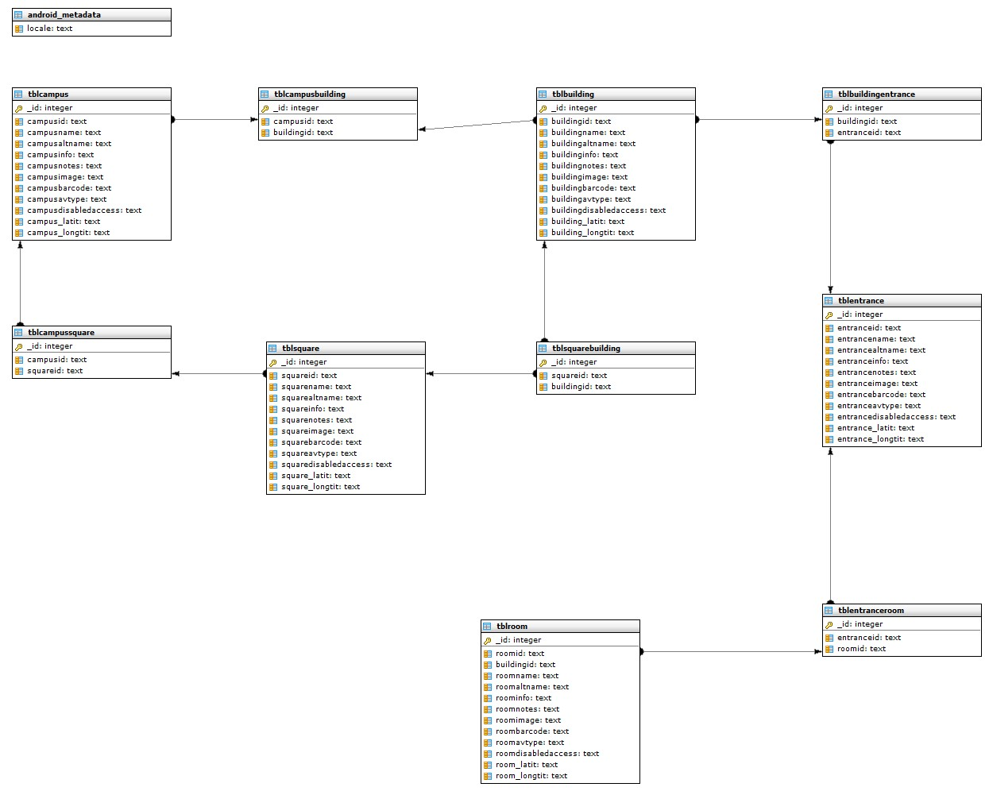
Database ERD
Here is the complete ER Diagram after refining the database, so it is now completed. It is as well filled with all data required for the purpose of this project.
Because I have kept in mind the limitations of processing power and resources on the mobile device I have designed the database so that it has primary keys and only logical connections. This way it would remain light without additional overhead as database logic is heavy on a mobile device and business logic will be handled in the design of the queries. As well some of the good practices of coding will be sacrificed, such as avoiding code repetition, in order to have less queries, this avoiding too much processing and memory consumption and saving battery life and providing a smoother user experience.
[5 hours]
[20 February 2011]
Today I consulted again my work colleague Alexandros Schillings about my GUI. He was very helpful and told me different techniques and best practices about tabs. He gave me advice on restructuring and nesting my XML layout design. He gave me pretty good ideas of steps I should take to achieve a good looking list representation of information and several other tips about the Tab layouts and functionalities.
To allow the user to refine search of entities such as buildings, rooms and such I used a simple TextView.[1]
[1]“TextView | Android Developers.” [Online]. Available: http://developer.android.com/reference/android/widget/TextView.html. [Accessed: 20-Feb-2011].
For representing the result of an user’s search I decided to use Android’s ListView[2].
[2]“ListView | Android Developers.” [Online]. Available: http://developer.android.com/reference/android/widget/ListView.html. [Accessed: 20-Feb-2011].
Sometime in the process of research and development I encountered a small problem with creating a ListView but I managed to resolve it thanks to the following topic.[3]
[3]“java - Android ListView that does not scroll? - Stack Overflow.” [Online]. Available: http://stackoverflow.com/questions/3192595/android-listview-that-does-not-scroll. [Accessed: 20-Feb-2011].
I had to do a bit of remodelling in the layout using this tutorial[4] and button properties manipulation using some of the practices shown here[5] to make them fit and look good and I had a very pleasant result of a well structured user interface.
[4]“Layout Tricks: Creating Efficient Layouts | Android Developers.” [Online]. Available: http://developer.android.com/resources/articles/layout-tricks-efficiency.html. [Accessed: 20-Feb-2011].
[5]“Learn Android: Linear layout.” [Online]. Available: http://android-pro.blogspot.com/2010/03/linear-layout.html. [Accessed: 20-Feb-2011].
I got the map to behave and look good in the tab layouts thanks to the help from this topic[6] and this blog[7].
[6]“java - Android - Tabs, MapView, activities within tabs - Stack Overflow.” [Online]. Available: http://stackoverflow.com/questions/1590340/android-tabs-mapview-activities-within-tabs. [Accessed: 20-Feb-2011].
[7]“Programming Android: Map View within Tab View Vladimir Kroz blog.” [Online]. Available: http://vkroz.wordpress.com/2009/07/03/programming-android-%e2%80%93-map-view-within-tab-view/. [Accessed: 20-Feb-2011].
[5 hours]
[26 February 2011]
A major problem I encountered was preserving the state of the GUI when the Android device is tilted on either portrait or landscape side. This is because this causes for the Android OS to re-call the applications “onCreate()” method as if the application has just been restarted.
I initially thought of using Android’s Serializable[1], Parcelable[2] and Intents[3] to store content in the background of the application.
[1]“Serializable | Android Developers.” [Online]. Available: http://developer.android.com/reference/java/io/Serializable.html. [Accessed: 26-Feb-2011].
[2]“Parcelable | Android Developers.” [Online]. Available: http://developer.android.com/reference/android/os/Parcelable.html. [Accessed: 26-Feb-2011].
[3]“Intents and Intent Filters | Android Developers.” [Online]. Available: http://developer.android.com/guide/topics/intents/intents-filters.html. [Accessed: 26-Feb-2011].
However I changed my mind and decided to go for a more crude approach and use static purpose-built classes to tackle this problem. The reason behind this is that even though static classes are not best programming practice, for the scale of this application they would be sufficient without unnecessary processing overhead. I will use Serializable[1], Parcelable[2] and Intents[3] in future development of the application when it grows and requires them.
[5 hours]

[15 March 2011]

I discovered a serious problem yesterday but since I thought it would be a simple fix I decided to leave it for today. My application does not scale on the tablet’s big screen and not only it does not look good, also the interface glitches sometime due to the incompatibility with the screen resolution.
After several hours of research and trying various methods I still cannot solve the problem.
[3 hours]

[16 March 2011]
After several more hours of research I finally solved the problem with the tablet screen resolution by manipulating the AnroidManifest.xml, sort of project master file:
<supports-screens android:smallScreens="true"
android:normalScreens="true" android:largeScreens="true"
android:anyDensity="true" />
Screen Support[1]

The solution was closer than I thought I found it on “Supporting Multiple Screens | Android Developers.”[1].
[1]“Supporting Multiple Screens | Android Developers.” [Online]. Available: http://developer.android.com/guide/practices/screens_support.html. [Accessed: 16-Mar-2011].
This way I allowed my application to support most devices’ screens’ sizes – small, normal and large.
I also added some code, form this topic[2], to programmatically lock the orientation of the application to portrait on the Android tablet so that when it is connected to the plasma TV it would not change orientation while I am demonstrating.
[2]“java - How to toggle orientation lock in android? - Stack Overflow.” [Online]. Available: http://stackoverflow.com/questions/2833474/how-to-toggle-orientation-lock-in-android. [Accessed: 16-Mar-2011].
Now the application and project are fully completed to standard and expectations and I am ready for the Open Day.
[4 hours]

